|  |  |  |
| --- | --- | --- |
| TECHNICAL TEST DEV SUPPORT | | |
|  |  |  |
| ANYAMAN HOSPITALITY | | |

# Profile Employer

Name : Mukhlis Aryanto

Role : Technical Support

Contact : 083869756993

Email : [aryantomukhlis@gmail.com](mailto:aryantomukhlis@gmail.com)

Github Repo : <https://github.com/mukhlisaryanto/DevSupport-AnyamanHospitality>

# Tools

1. PHP version 8.1.25
2. Xampp
3. WebStrom Code Editor
4. Github
5. Node JS version 20.13.0
6. Laravel Framework
7. Postman

# Database Api-Nilai

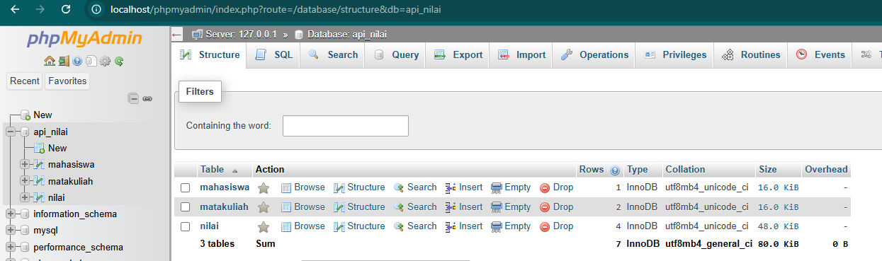

Gambar . List of table

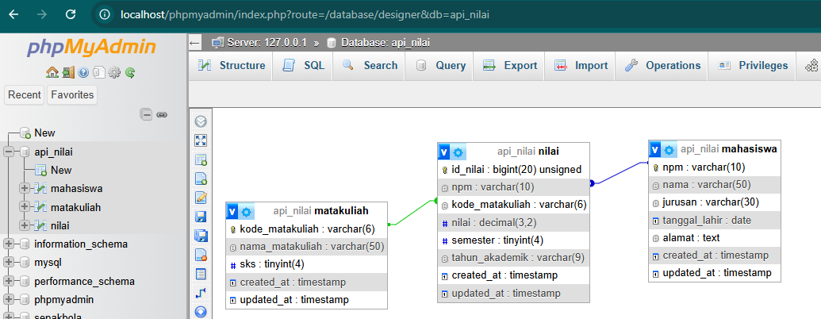

Gambar . Schema Database Api-Nilai

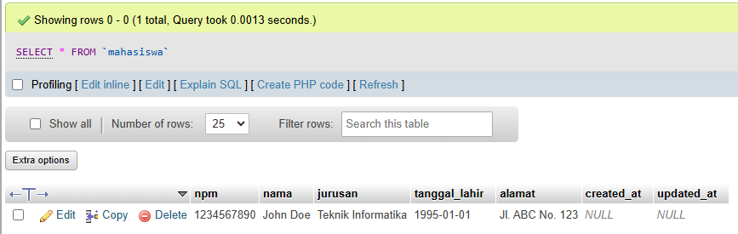

Table . Mahasiswa

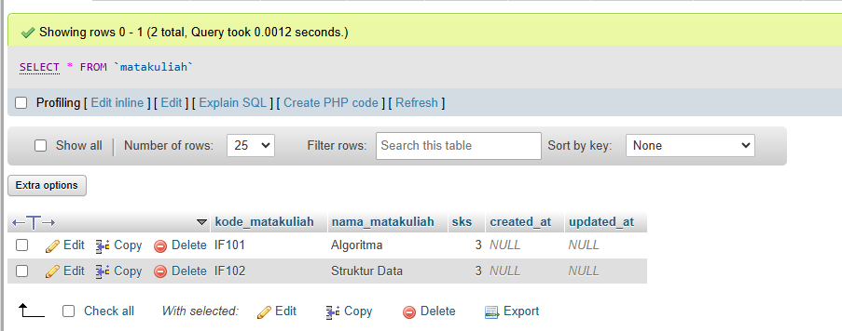

Table . Matakuliah

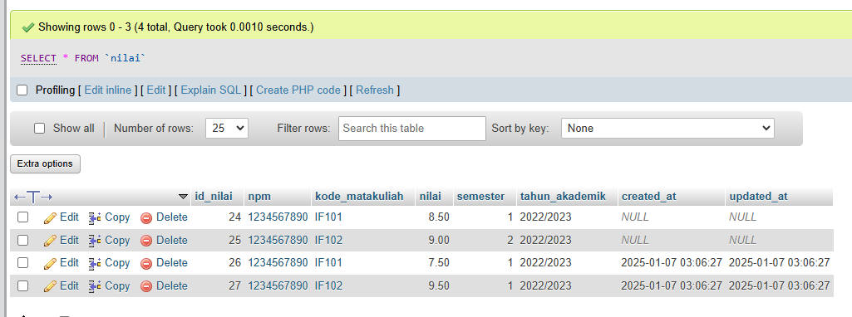

Table . Nilai

# Web Service API Post Data Nilai

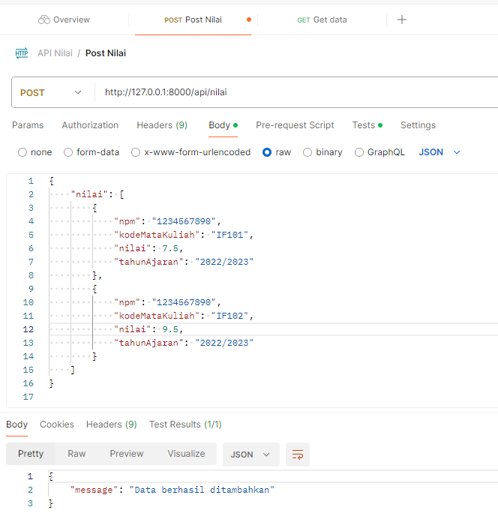

# Web Service API Get Data Response

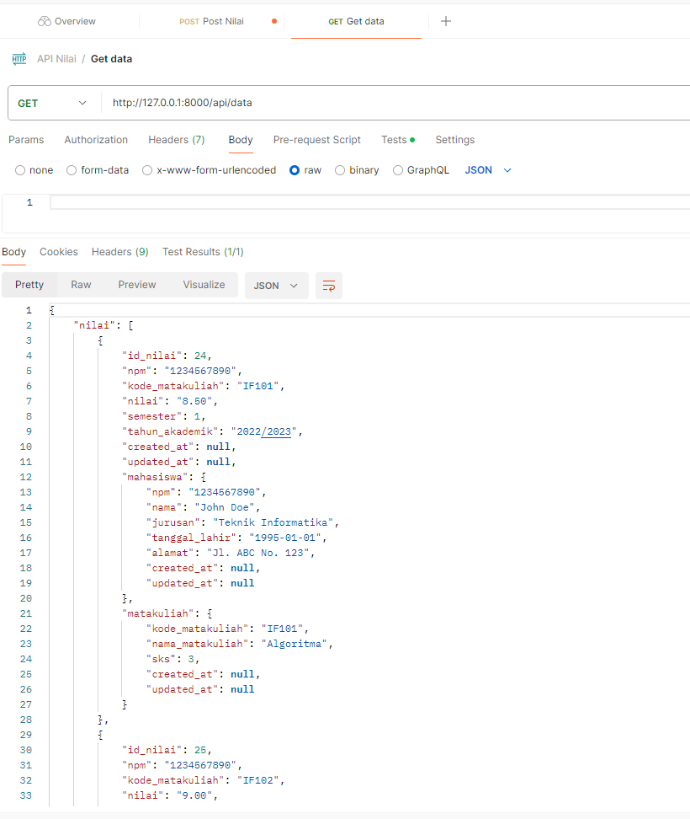

# Define Response Get Data in resource > js >app.js

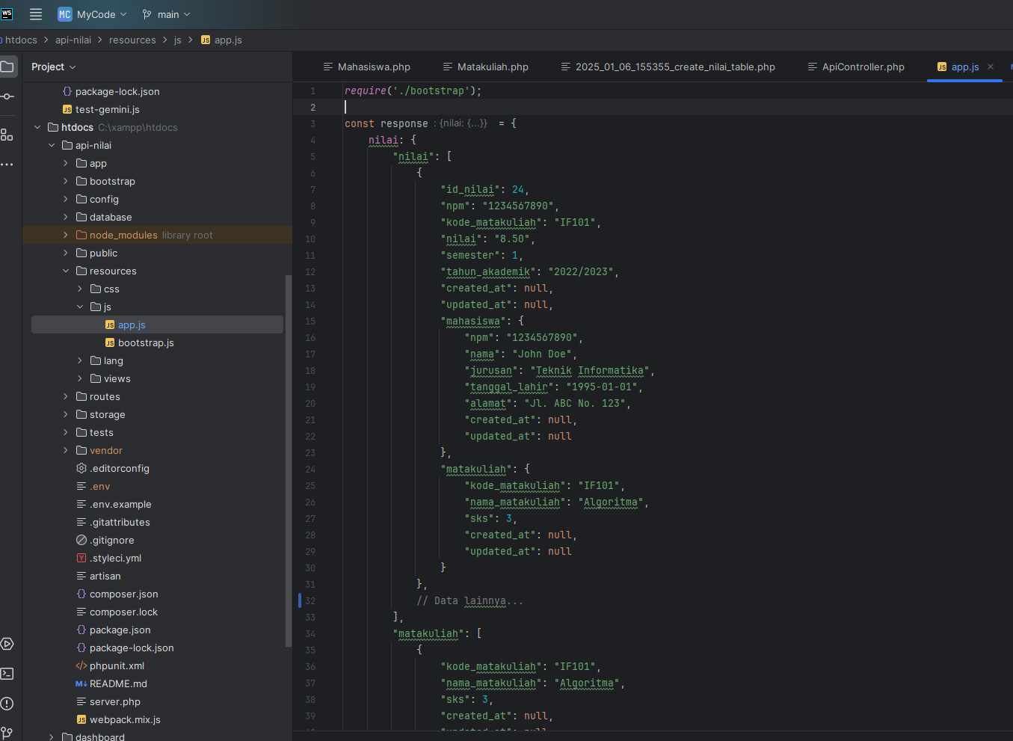

# Array Filter with key mahasiswa from reponse json

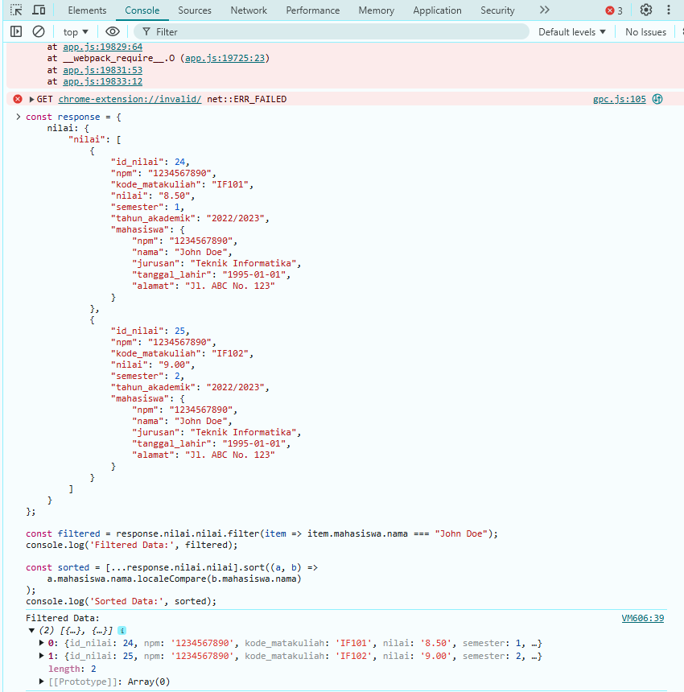

# Array Data Sort with key mahasiswa from response json

